**Statistics with R Specialization**

**Course 2: Inferential Statistics**

**CLT and Sampling**

**

**t-distribution and comparing two means**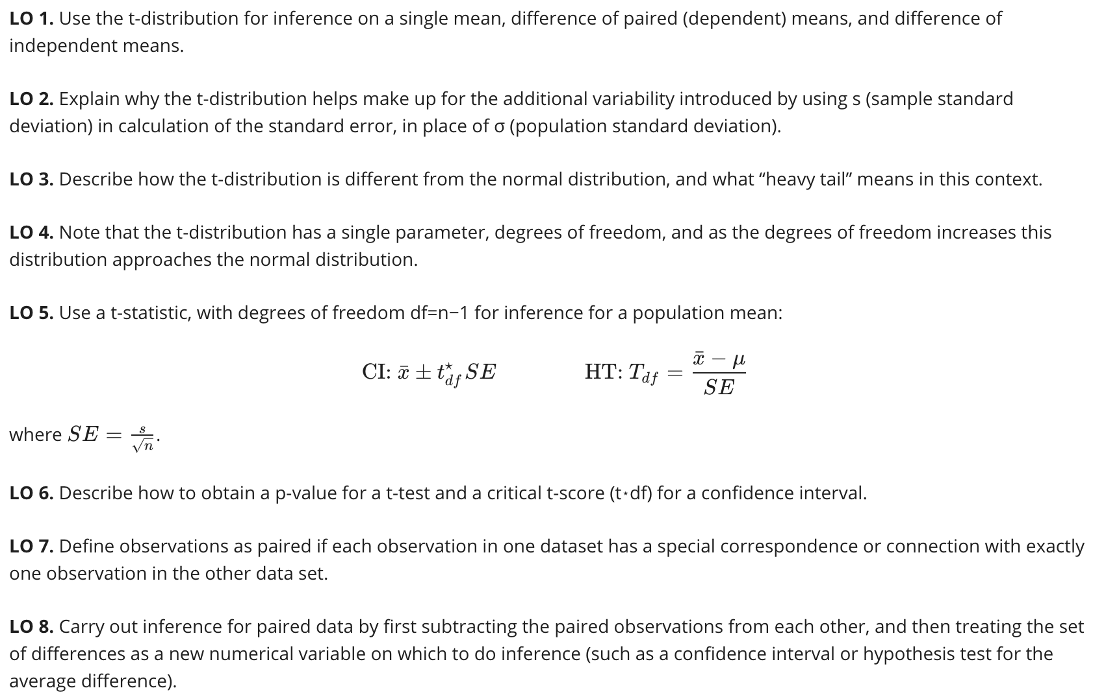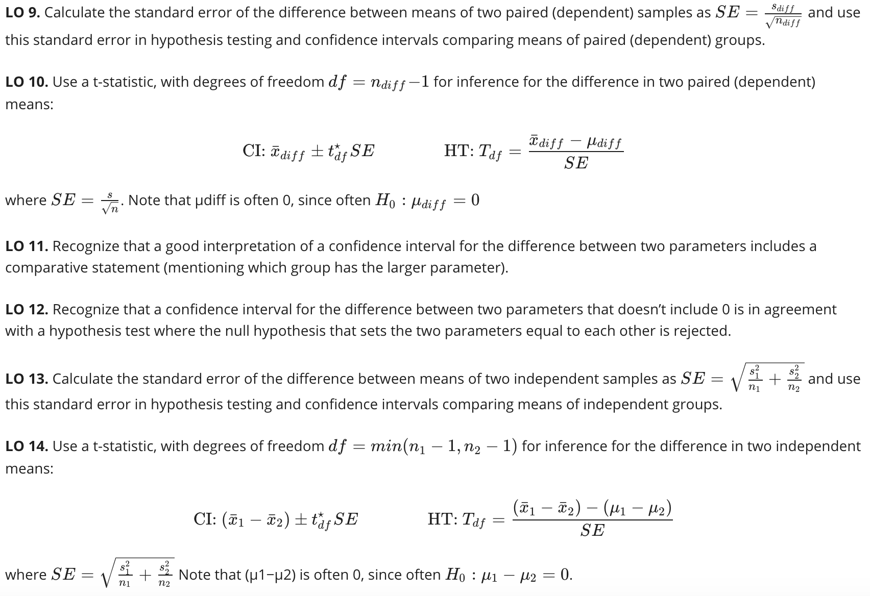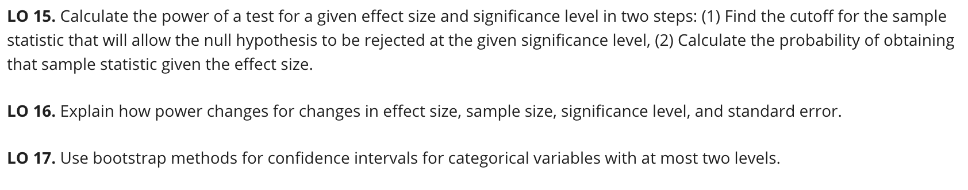

**ANOVA and bootstrapping**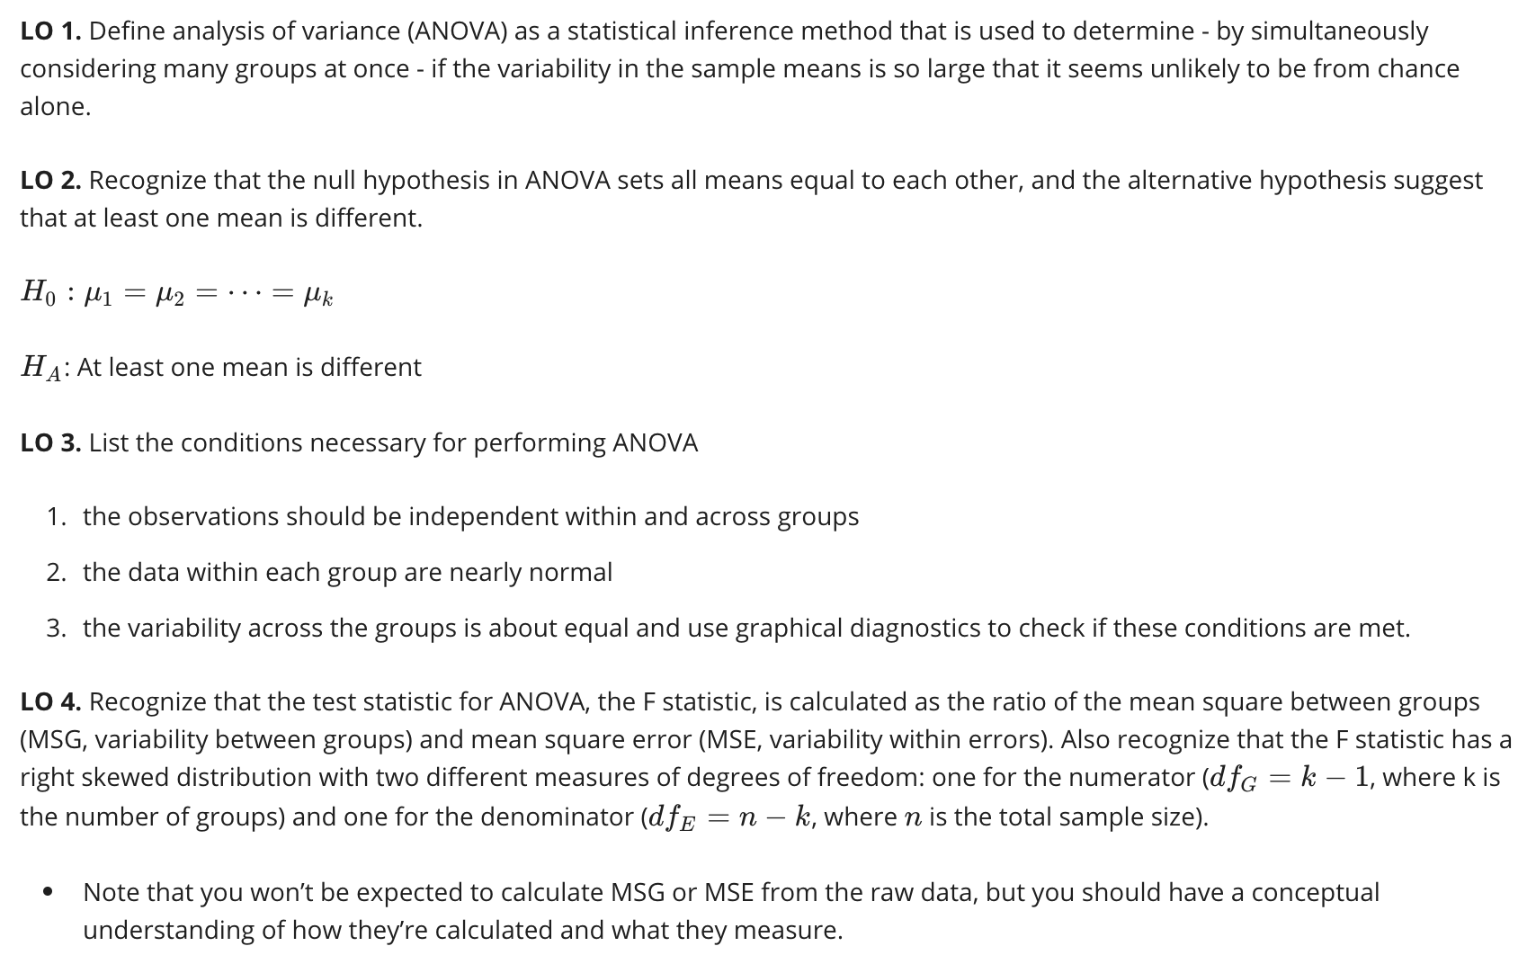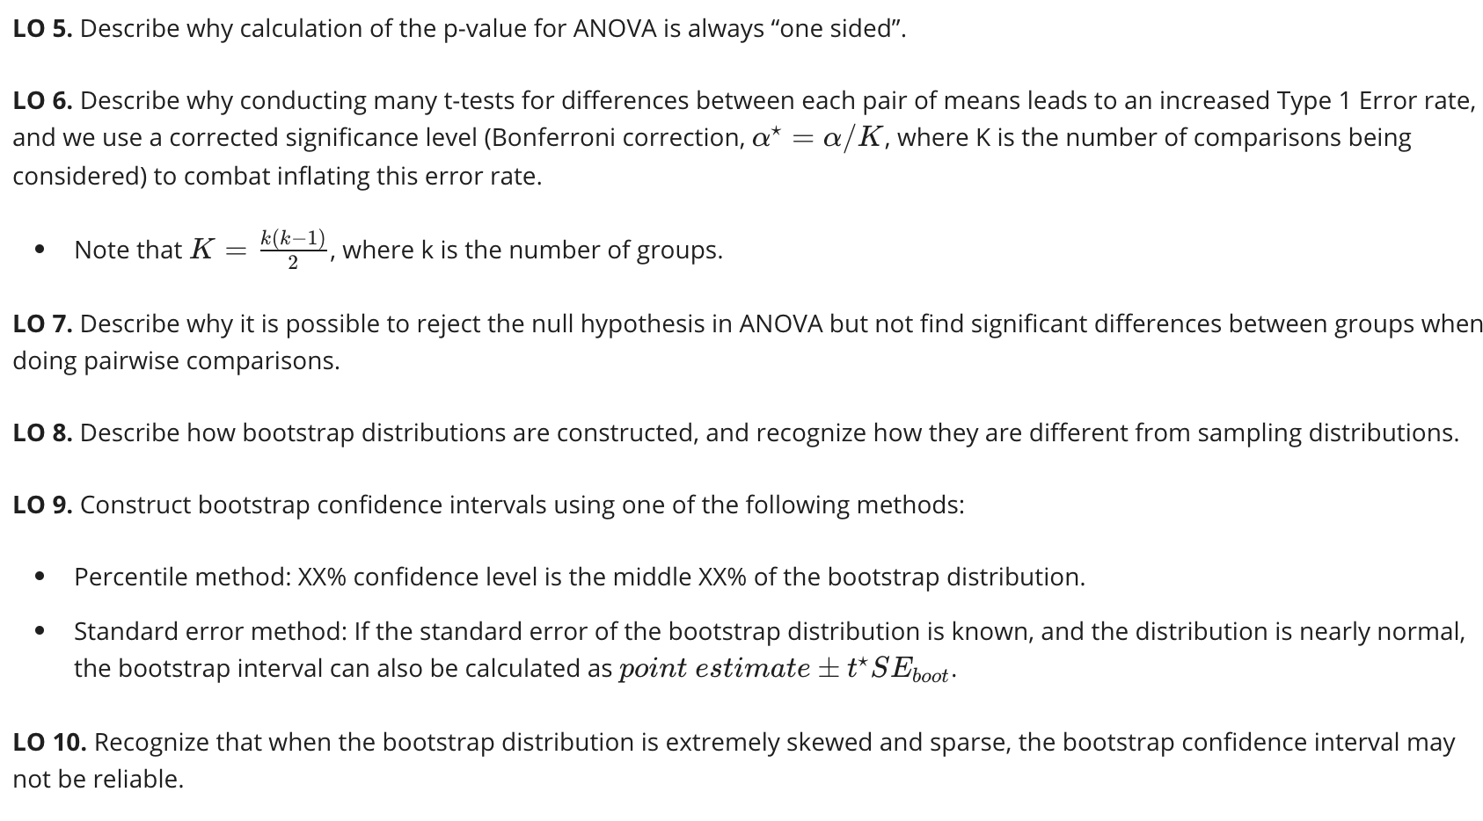

**Inference for proportions**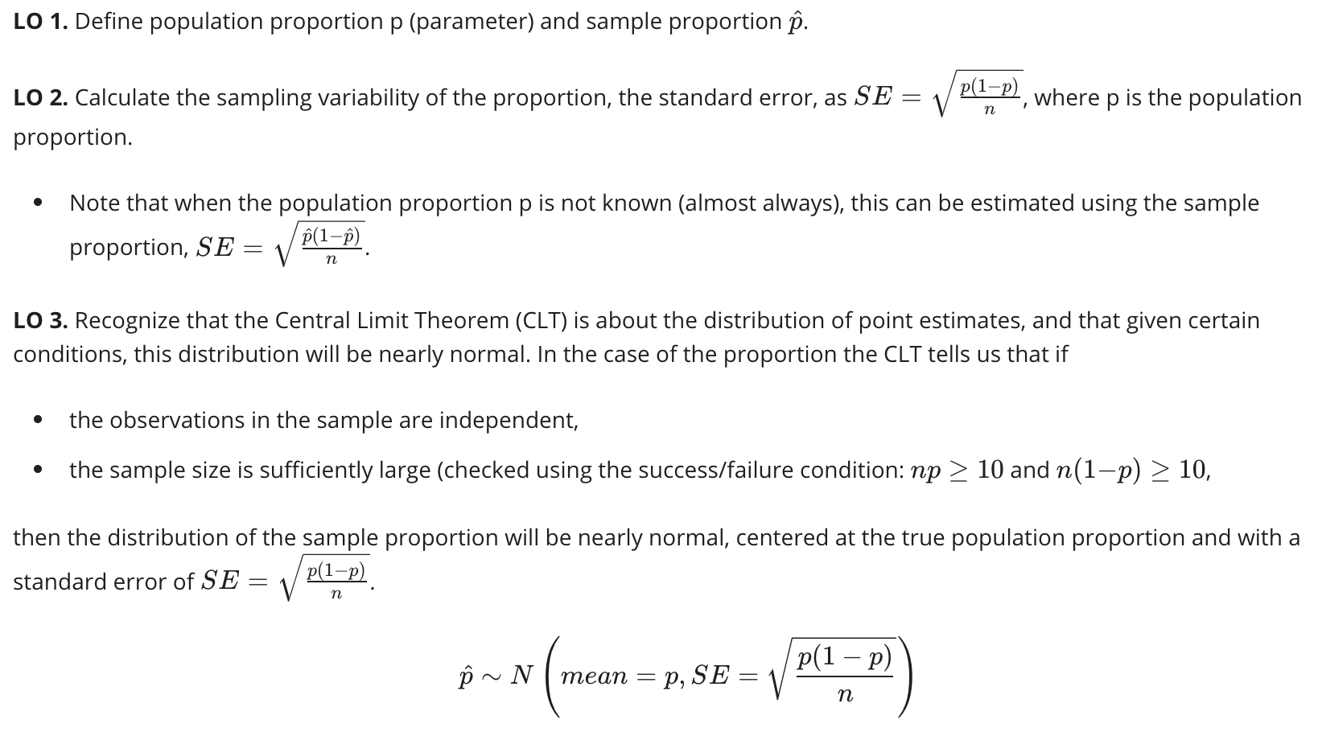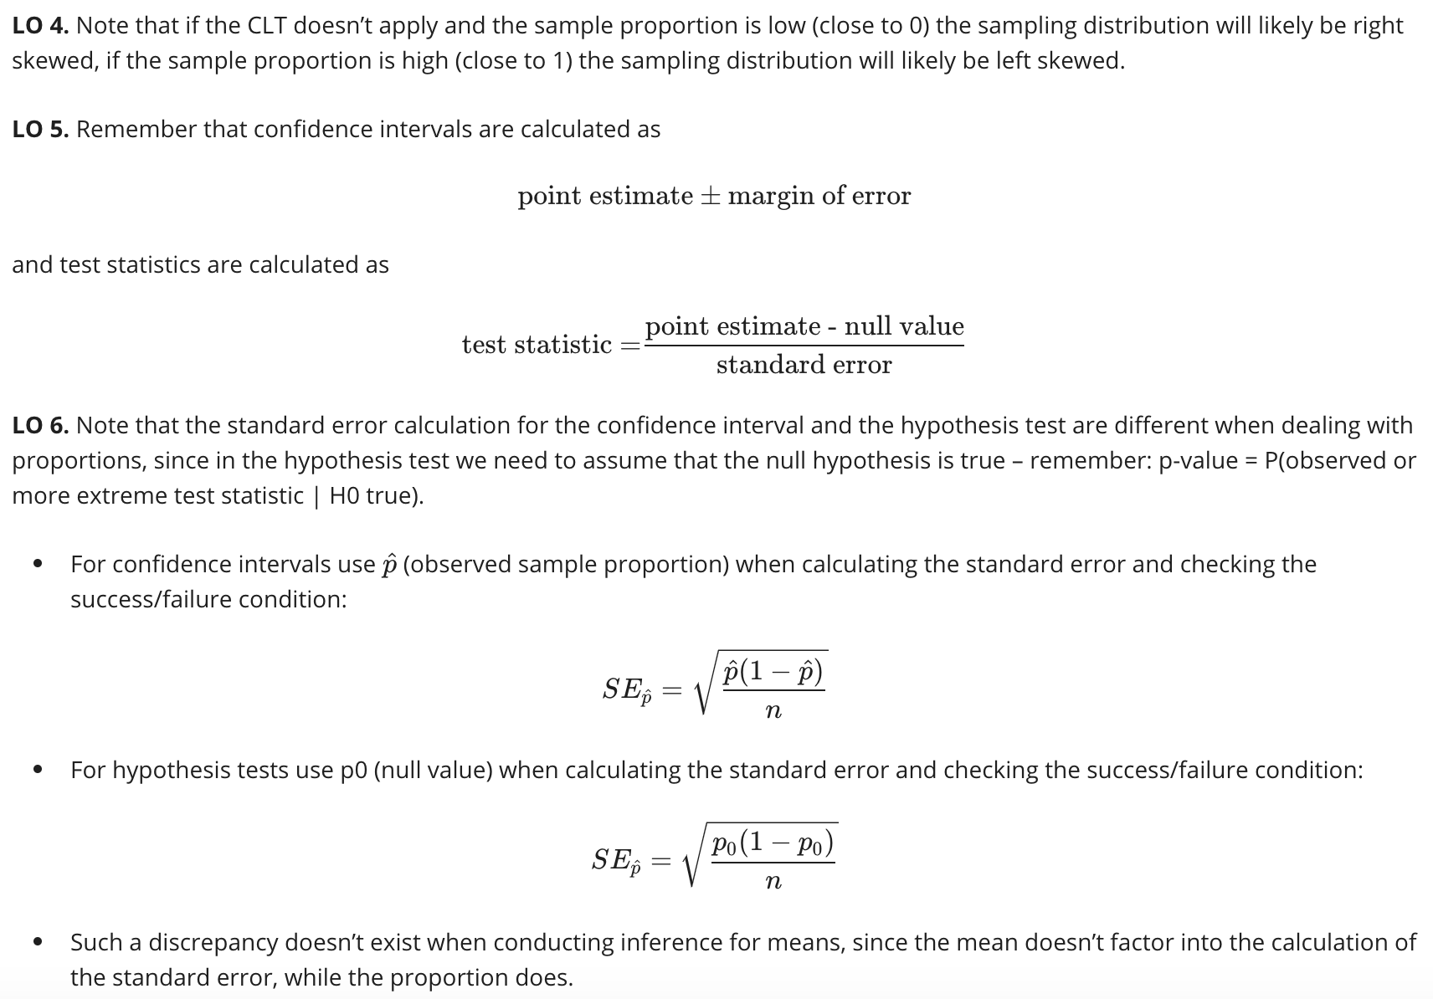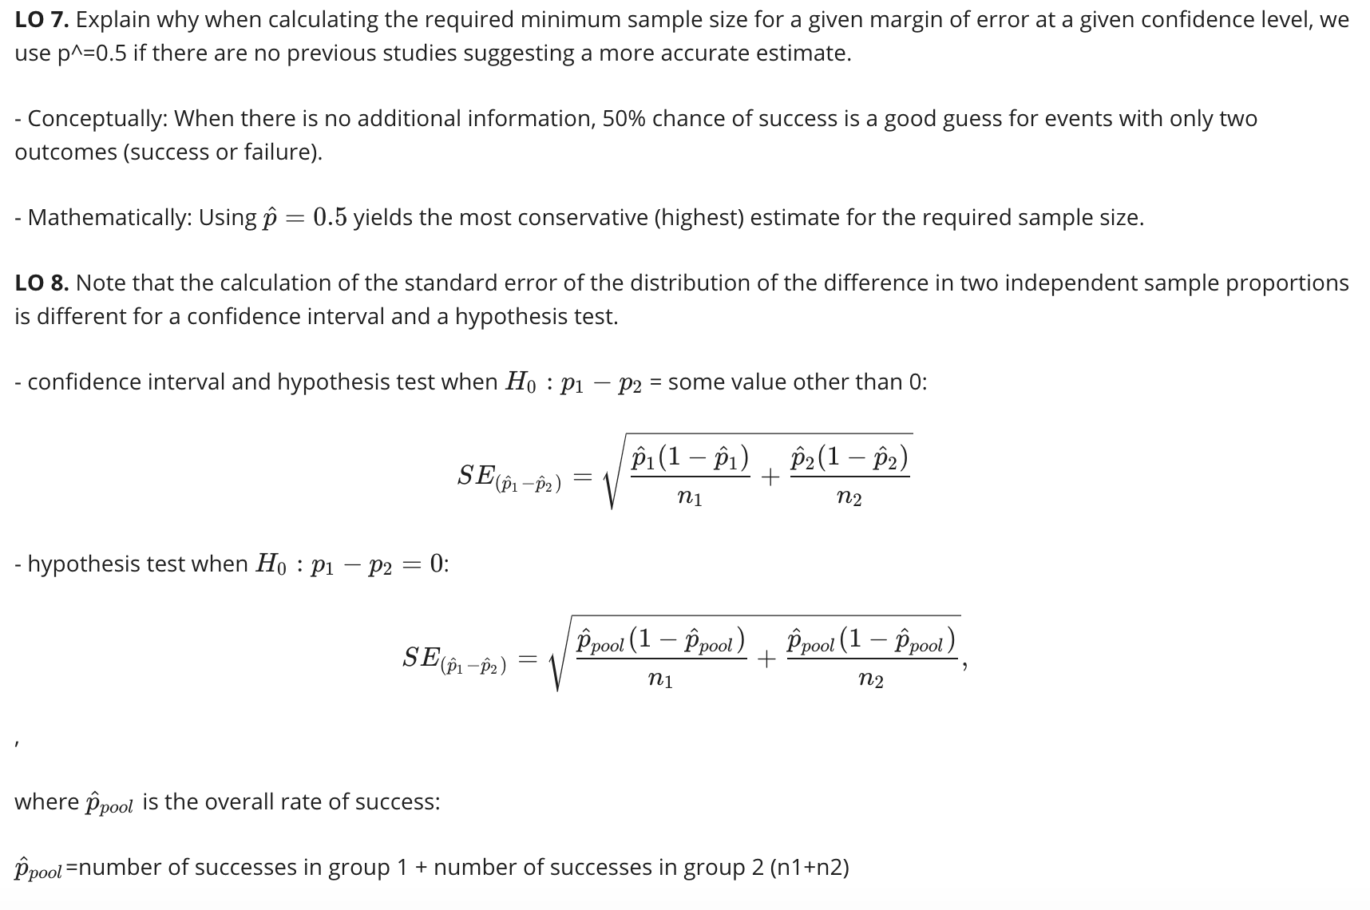

**Simulation based inference for proportions and chi-square testing**